Part 2

Develop the client-side in AngularJS to allow a user to enter a login name and password that is transferred to the Node.js server.

AngularJs:

app/src/app/module.ts – all imports placed here

app/src/app/login – generated component from command: *ng g c login*

*ng g c* “component_name” – to generate new component

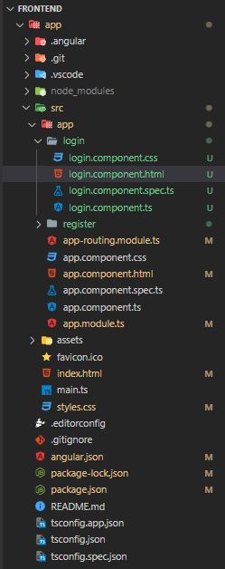

app/src/app.module.ts :

import { NgModule } from '@angular/core';

import { BrowserModule } from '@angular/platform-browser';

import { AppRoutingModule } from './app-routing.module';

import { AppComponent } from './app.component';

import { BrowserAnimationsModule } from '@angular/platform-browser/animations';

import { LoginComponent } from './login/login.component';

import { FlexLayoutModule } from '@angular/flex-layout';

import {MatFormFieldModule} from '@angular/material/form-field';

import {MatCardModule} from '@angular/material/card';

import {MatButtonModule} from '@angular/material/button';

import {MatInputModule} from '@angular/material/input';

import {MatDividerModule} from '@angular/material/divider';

import {MatToolbarModule} from '@angular/material/toolbar';

import {HttpClientModule} from '@angular/common/http';

import {FormsModule} from '@angular/forms';

@NgModule({

  declarations: [

    AppComponent,

    LoginComponent,

  ],

  imports: [

    BrowserModule,

    AppRoutingModule,

    BrowserAnimationsModule,

    FlexLayoutModule,

    MatFormFieldModule,

    MatCardModule,

    MatButtonModule,

    MatInputModule,

    MatDividerModule,

    MatToolbarModule,

    HttpClientModule,

    FormsModule

  ],

  providers: [],

  bootstrap: [AppComponent]

})

export class AppModule { }

app/src/app.component.html :

<router-outlet></router-outlet>

App/src/app-routing.module.ts

import { NgModule } from '@angular/core';

import { RouterModule, Routes } from '@angular/router';

import { LoginComponent } from './login/login.component';

const routes: Routes = [

  {path: "", component: LoginComponent},

];

@NgModule({

  imports: [RouterModule.forRoot(routes)],

  exports: [RouterModule]

})

export class AppRoutingModule { }

app/src/login/login.component.ts :

import { HttpClient } from '@angular/common/http';

import { Component } from '@angular/core';

@Component({

  selector: 'app-login',

  templateUrl: './login.component.html',

  styleUrls: ['./login.component.css']

})

export class LoginComponent {

  constructor(private http:HttpClient){}

  onLogin(loginData:  {

    username: string,

    password: string

  }) {

// call nodejs application api

    const req = this.http.post("http://localhost:8000/user/login", loginData).subscribe((req) => {

      console.log(req)

    })

  }

}

App/src/login/login.component.ts :

<div fxLayoutAlign="center center" fxFlexFill>

  <mat-card fxFlex="20">

    <mat-toolbar color="warn">

      Login

    </mat-toolbar>

    <form class="form" #login="ngForm" (ngSubmit)="onLogin(login.value)" fxLayoutAlign="stretch" fxLayout="column">

      <mat-form-field appearance="fill">

        <mat-label>Username</mat-label>

        <input name="username" id="username" matInput ngModel>

      </mat-form-field>

      <mat-form-field appearance="fill">

        <mat-label>Password</mat-label>

        <input name="password" id="password" type="password" matInput ngModel>

      </mat-form-field>

      <button type="submit" mat-raised-button color="primary">Login</button>

      <mat-divider>or</mat-divider>

      <a mat-raised-button  [routerLink]="['/register']" target="">Register</a>

    </form>

  </mat-card>

</div>

App/package.json

{

  "name": "app",

  "version": "0.0.0",

  "scripts": {

    "ng": "ng",

    "start": "ng serve",

    "build": "ng build",

    "watch": "ng build --watch --configuration development",

    "test": "ng test"

  },

  "private": true,

  "dependencies": {

    "@angular/animations": "^15.1.0",

    "@angular/cdk": "^15.1.1",

    "@angular/common": "^15.1.0",

    "@angular/compiler": "^15.1.0",

    "@angular/core": "^15.1.0",

    "@angular/flex-layout": "^14.0.0-beta.41",

    "@angular/forms": "^15.1.0",

    "@angular/material": "^15.1.1",

    "@angular/platform-browser": "^15.1.0",

    "@angular/platform-browser-dynamic": "^15.1.0",

    "@angular/router": "^15.1.0",

    "rxjs": "~7.8.0",

    "tslib": "^2.3.0",

    "zone.js": "~0.12.0"

  },

  "devDependencies": {

    "@angular-devkit/build-angular": "^15.1.2",

    "@angular/cli": "~15.1.2",

    "@angular/compiler-cli": "^15.1.0",

    "@types/jasmine": "~4.3.0",

    "jasmine-core": "~4.5.0",

    "karma": "~6.4.0",

    "karma-chrome-launcher": "~3.1.0",

    "karma-coverage": "~2.2.0",

    "karma-jasmine": "~5.1.0",

    "karma-jasmine-html-reporter": "~2.0.0",

    "typescript": "~4.9.4"

  }

}

TEST DATA:

username: test

password: test_pass

Request:

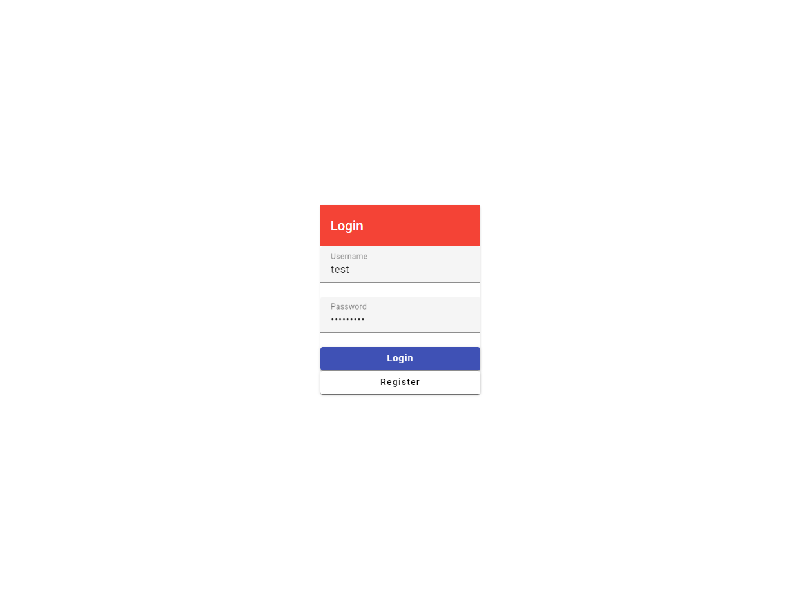

Response:

